

**machine learning report (Regression project STUDENTS’ EXAM SCORES)**

**By:**

|  |  |
| --- | --- |
| Name | ID |
| **Ahmed Sofi** | 42010635 |

**Under the Supervision of:**

Eng. Ahmed Nousir

Contents

1. Introduction 3
2. The Problem understanding: 3
   1. Data Description 3
   2. Problem Statement 3
3. Data Exploration 3
   1. Descriptive Statistics 3
   2. Correlation Analysis 4
4. Data Preprocessing 5
   1. Handling Missing Values 5
   2. Encoding Categorical Variables 5
   3. Feature Scaling 5
5. Model Building 5
   1. Splitting Data 5
   2. Model Selection 5
   3. Training the Model 5
   4. Model Evaluation 5
6. Conclusion 6

Figure 1 Statistics for data 4

Figure 2 Correlation 4

Figure 3 plots 4

Figure 5 Accuracy 6

# Introduction

This dataset includes scores from three test scores of students at a (fictional) public school and a variety of personal and socio-economic factors that may have interaction effects upon them.

# The Problem understanding:

The data set is about scores of students this data contain 14 columns and 30641 rows

## Data Description

Explain the importance of each column in the data set. Highlighting the role of factors such as the type of school lunch and the number of siblings a student has on the student’s overall grades.

## Problem Statement

Define the problem statement clearly. For example, you could state that the goal is to predict based on various factors in the dataset.

# Data Exploration

This data from Kaggle is about 30641 rows and 14 columns in his part we need to get more information about data and another statistics.

## Descriptive Statistics

Provide summary statistics for each column. This could include mean, median, standard deviation, and other relevant metrics. Identify any trends or patterns.

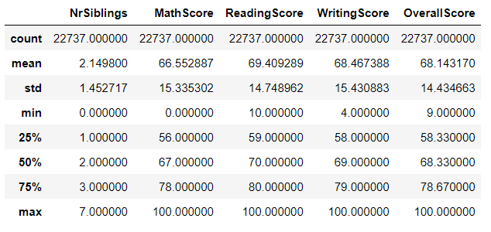

Figure 1 Statistics for data

## Correlation Analysis

Explore the correlation between all columns.

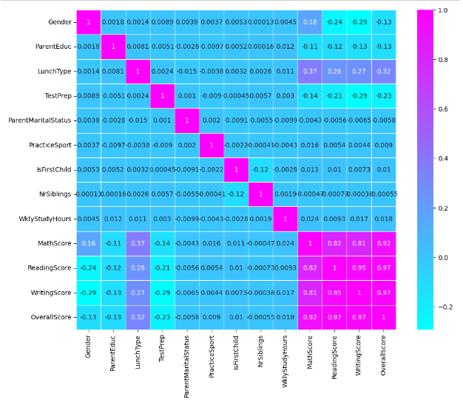

Figure 2 Correlation

**3.3 Visualizations**

P a g e

# Data Preprocessing

This part for clean data from nulls and duplicates and check outliers to make data ready for deploy model.

## Handling Missing Values

Address any missing values in the dataset through imputation or removal.

## Encoding Categorical Variables

If there are categorical variables, encode them into numerical format for model compatibility.

## Feature Scaling

Normalize or standardize numerical features if necessary to ensure fair treatment by the model.

# Model Building

## Splitting Data

Divide the dataset into training and testing sets.

## Model Selection

Choose a suitable machine learning model for the task (e.g., Random Forest, Linear Regreesion).

## Training the Model

Train the chosen model on the training dataset.

## Model Evaluation

Evaluate the model's performance on the testing dataset. Mention metrics such as accuracy, precision, recall, and F1 score.

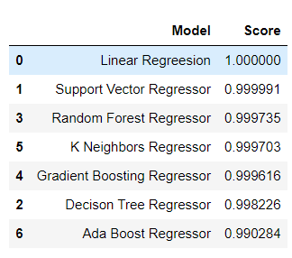

Figure 4 Accuracy

# Conclusion

Summarize the key findings and insights from the analysis. Discuss the limitations and potential areas for improvement. Offer recommendations for further research or model enhancements.